#### 3.3.3. CFFE-Admin (Mobile)

**a. Overview**

Application used by admin when want to:

+ Login

+ Logout

+ View statistics

+ View video

+ Manage manager

+ Manage store

+ Manage camera

+ Manage product

+ Manage category

+ Manage own profile

Hình của Luận

**b. Login page:**



|  |  |
| --- | --- |
| **Step** | **Description** |
| 1 | Admin inputs the account. |
| 2 | Admin clicks the “Login” button. |

**c. Dashboard page:**



|  |  |
| --- | --- |
| **Step** | **Description** |
| 1 | Admin clicks the “navigator” icon to view drawer navigator. |
| 2 | Admin clicks the “Profile” item to view own profile. |
| 3 | Admin clicks the “Logout” item to logout from the application. |

**d. Profile page.**



|  |  |
| --- | --- |
| **Step** | **Description** |
| 1 | Admin clicks the item to change own information. |
| 2 | Admin clicks the item to change own avatar. |
| 3 | Admin clicks the item to change own password. |

1. Change own information.



|  |  |
| --- | --- |
| **Step** | **Description** |
| 1 | Admin clicks the “back” icon to cancel the command. |
| 2 | Admin edits the information. |
| 3 | Admin clicks the “Save” button to change own information |

2. Change own avatar.

 

|  |  |
| --- | --- |
| **Step** | **Description** |
| 1 | Admin clicks the “back” icon to cancel the command. |
| 2 | Admin clicks the “camera” icon to choose image from mobile. |
| 3 | Admin clicks the “Save” button to change own avatar. |

3. Change own password



|  |  |
| --- | --- |
| **Step** | **Description** |
| 1 | Admin clicks the “back” icon to cancel the command. |
| 2 | Admin inputs the information. |
| 3 | Admin clicks the “Update” button to change own password. |

**e. Video page**



|  |  |
| --- | --- |
| **Step** | **Description** |
| 1 | Admin chooses the value of filter to search the video. |
| 2 | Admin clicks the “Search” button to search the video. |
| 3 | Admin clicks the item to view the video detail page. |

**f. Manager page**



|  |  |
| --- | --- |
| **Step** | **Description** |
| 1 | Admin inputs the search value and chooses the value of filter. |
| 2 | Admin clicks the item to view the manager detai page. |
| 3 | Admin clicks the “Add” icon to create the manager. |

1. Create the manager



|  |  |
| --- | --- |
| **Step** | **Description** |
| 1 | Admin clicks the “back” icon to cancel the command. |
| 2 | Admin inputs the manager’s information. |
| 3 | Admin clicks the “Create” button to create the manager. |

**g. Manager Detail Page**

 

|  |  |
| --- | --- |
| **Step** | **Description** |
| 1 | Admin clicks the item to change the manager’s information. |
| 2 | Admin clicks the item to change the manager’s avatar. |
| 3 | Admin clicks the item to reset the manager’s password. |
| 4 | Admin clicks the item to delete the manager. |
| 5 | Admin clicks the “Choose Store” button to choose the store from the manager. |
| 6 | Admin clicks the “Remove Store” button remove the store from the manager. |

1. Change the manager’s information



|  |  |
| --- | --- |
| **Step** | **Description** |
| 1 | Admin clicks the “back” icon to cancel the command. |
| 2 | Admin inputs the manager’s information. |
| 3 | Admin clicks the “Save” button to change the manager’s information. |

2. Change the manager’s avatar.

 

|  |  |
| --- | --- |
| **Step** | **Description** |
| 1 | Admin clicks the “back” icon to cancel the command. |
| 2 | Admin clicks the “camera” icon to choose image from mobile. |
| 3 | Admin clicks the “Save” button to change the manager’s avatar. |

3. Reset the manager’s password.



|  |  |
| --- | --- |
| **Step** | **Description** |
| 1 | Admin clicks the “No” button to cancel the command. |
| 2 | Admin clicks the “Yes” button to reset the manager’s password. |

4. Delete the manager



|  |  |
| --- | --- |
| **Step** | **Description** |
| 1 | Admin clicks the “back” icon to cancel the command. |
| 2 | Admin inputs an inactive reason. |
| 3 | Admin clicks the “Save” button to delete the manager. |

5.Add the store into the manager

 

|  |  |
| --- | --- |
| **Step** | **Description** |
| 1 | Admin inputs the search value to find the store by store name. |
| 2 | Admin chooses the store item. |
| 3 | Admin clicks the “No” button to cancel the command. |
| 4 | Admin clicks the “Yes” button to add the store into the manager. |

6. Remove the store from the manager.



|  |  |
| --- | --- |
| **Step** | **Description** |
| 1 | Admin clicks the “No” button to cancel the command. |
| 2 | Admin clicks the “Yes” button to remove the store from the manager. |

**e. Store page**



|  |  |
| --- | --- |
| **Step** | **Description** |
| 1 | Admin inputs the search value and chooses the value of filter. |
| 2 | Admin clicks the item to view the store detai page. |
| 3 | Admin clicks the “Add” icon to create the store. |

1. Create the store



|  |  |
| --- | --- |
| **Step** | **Description** |
| 1 | Admin clicks the “back” icon to cancel the command. |
| 2 | Admin inputs the store’s information. |
| 3 | Admin clicks the “Create” button to create the store. |

**f. Store detail page**

 

|  |  |
| --- | --- |
| **Step** | **Description** |
| 1 | Admin clicks the item to change the store’s information. |
| 2 | Admin clicks the item to change the store’s image. |
| 3 | Admin clicks the item to delete the store. |
| 4 | Admin clicks the “Choose Manager” button to choose the manager from the store. |
| 5 | Admin clicks the “Remove Manager” button remove the manager from the store. |
| 3 | Admin clicks the item to reset the manager’s password. |

1. Change the store’s information



|  |  |
| --- | --- |
| **Step** | **Description** |
| 1 | Admin clicks the “back” icon to cancel the command. |
| 2 | Admin inputs the store’s information. |
| 3 | Admin clicks the “Save” button to change the store’s information. |

2. Change the store’s image.



|  |  |
| --- | --- |
| **Step** | **Description** |
| 1 | Admin clicks the “back” icon to cancel the command. |
| 2 | Admin clicks the “camera” icon to choose image from mobile. |
| 3 | Admin clicks the “Save” button to change the store’s image. |

3. Delete the store.



|  |  |
| --- | --- |
| **Step** | **Description** |
| 1 | Admin clicks the “back” icon to cancel the command. |
| 2 | Admin inputs an inactive reason. |
| 3 | Admin clicks the “Save” button to delete the store. |

4. Add the manager into the store

 

|  |  |
| --- | --- |
| **Step** | **Description** |
| 1 | Admin inputs the search value to find the manager by full name. |
| 2 | Admin chooses the manager item. |
| 3 | Admin clicks the “No” button to cancel the command. |
| 4 | Admin clicks the “Yes” button to add the manager into the store. |

5. Remove the manager from the store



|  |  |
| --- | --- |
| **Step** | **Description** |
| 1 | Admin clicks the “No” button to cancel the command. |
| 2 | Admin clicks the “Yes” button to remove the manager from the store. |

**f. Camera page**



|  |  |
| --- | --- |
| **Step** | **Description** |
| 1 | Admin inputs the search value and chooses the value of filter. |
| 2 | Admin clicks the item to view the camera detai page. |
| 3 | Admin clicks the “Add” icon to create the camera. |

2. Create the camera



|  |  |
| --- | --- |
| **Step** | **Description** |
| 1 | Admin clicks the “back” icon to cancel the command. |
| 2 | Admin inputs the camera’s information. |
| 3 | Admin clicks the “Create” button to create the camera. |

**g. Camera detail**



|  |  |
| --- | --- |
| **Step** | **Description** |
| 1 | Admin clicks the item to change the camera’s information. |
| 2 | Admin clicks the item to change the camera’s image. |
| 3 | Admin clicks the item to delete the camera. |

1. Change the camera’s information



|  |  |
| --- | --- |
| **Step** | **Description** |
| 1 | Admin clicks the “back” icon to cancel the command. |
| 2 | Admin inputs the camera’s information. |
| 3 | Admin clicks the “Save” button to change the camera’s information. |

2. Change the camera’s image.

 

|  |  |
| --- | --- |
| **Step** | **Description** |
| 1 | Admin clicks the “back” icon to cancel the command. |
| 2 | Admin clicks the “camera” icon to choose image from mobile. |
| 3 | Admin clicks the “Save” button to change the camera’s image. |

3. Delete the camera



|  |  |
| --- | --- |
| **Step** | **Description** |
| 1 | Admin clicks the “back” icon to cancel the command. |
| 2 | Admin inputs an inactive reason. |
| 3 | Admin clicks the “Save” button to delete the camera. |

**h. Product page**



|  |  |
| --- | --- |
| **Step** | **Description** |
| 1 | Admin inputs the search value and chooses the value of filter. |
| 2 | Admin clicks the item to view the product detai page. |
| 3 | Admin clicks the “Add” icon to create the product. |

1. Create the product



|  |  |
| --- | --- |
| **Step** | **Description** |
| 1 | Admin clicks the “back” icon to cancel the command. |
| 2 | Admin inputs the product’s information. |
| 3 | Admin clicks the “Create” button to create the product. |

**i. Product detail page**



|  |  |
| --- | --- |
| **Step** | **Description** |
| 1 | Admin clicks the item to change the product’s information. |
| 2 | Admin clicks the item to change the product’s image. |
| 3 | Admin clicks the item to delete the product. |

1. Change the product’s information.



|  |  |
| --- | --- |
| **Step** | **Description** |
| 1 | Admin clicks the “back” icon to cancel the command. |
| 2 | Admin inputs the product’s information. |
| 3 | Admin clicks the “Save” button to change the product’s information. |

2. Change the product’s image

 

|  |  |
| --- | --- |
| **Step** | **Description** |
| 1 | Admin clicks the “back” icon to cancel the command. |
| 2 | Admin clicks the “camera” icon to choose image from mobile. |
| 3 | Admin clicks the “Save” button to change the product’s image. |

3. Delete the product



|  |  |
| --- | --- |
| **Step** | **Description** |
| 1 | Admin clicks the “back” icon to cancel the command. |
| 2 | Admin inputs an inactive reason. |
| 3 | Admin clicks the “Save” button to delete the product. |

**j. Category page**



|  |  |
| --- | --- |
| **Step** | **Description** |
| 1 | Admin inputs the search value and chooses the value of filter. |
| 2 | Admin clicks the item to view the category detai page. |
| 3 | Admin clicks the “Add” icon to create the category. |

1. Create the category



|  |  |
| --- | --- |
| **Step** | **Description** |
| 1 | Admin clicks the “back” icon to cancel the command. |
| 2 | Admin inputs the category’s information. |
| 3 | Admin clicks the “Create” button to create the category. |

**k. Category detail page**



|  |  |
| --- | --- |
| **Step** | **Description** |
| 1 | Admin clicks the item to change the category’s information. |
| 2 | Admin clicks the item to delete the category. |

1. Change the category’s information.



|  |  |
| --- | --- |
| **Step** | **Description** |
| 1 | Admin clicks the “back” icon to cancel the command. |
| 2 | Admin inputs the category’s information. |
| 3 | Admin clicks the “Save” button to change the category’s information. |

2. Delete the category



|  |  |
| --- | --- |
| **Step** | **Description** |
| 1 | Admin clicks the “No” button to cancel the command. |
| 2 | Admin clicks the “Yes” button to delete the category. |

#### 3.3.4. CFFE-Manager (Mobile)

**a. Overview**

Application used by admin when want to:

+ Login

+ Logout

+ Manage own profile

+ View statistics

+ View video

+ Manage shelf

+ Manage stack

+ Manage camera

+ Manage product

**b. Login page:**



|  |  |
| --- | --- |
| **Step** | **Description** |
| 1 | Manager inputs the account. |
| 2 | Manager clicks the “Login” button. |

**c. Dashboard page:**



|  |  |
| --- | --- |
| **Step** | **Description** |
| 1 | Manager clicks the “navigator” icon to view drawer navigator. |
| 2 | Manager clicks the “Profile” item to view own profile. |
| 3 | Manager clicks the “Logout” item to logout from the application. |

**d. Profile page.**



|  |  |
| --- | --- |
| **Step** | **Description** |
| 1 | Manager clicks the item to change own information. |
| 2 | Manager clicks the item to change own avatar. |
| 3 | Manager clicks the item to change own password. |

1. Change own information.



|  |  |
| --- | --- |
| **Step** | **Description** |
| 1 | Manager clicks the “back” icon to cancel the command. |
| 2 | Manager edits the information. |
| 3 | Manager clicks the “Save” button to change own information |

2. Change own avatar.

 

|  |  |
| --- | --- |
| **Step** | **Description** |
| 1 | Manager clicks the “back” icon to cancel the command. |
| 2 | Manager clicks the “camera” icon to choose image from mobile. |
| 3 | Manager clicks the “Save” button to change own avatar. |

3. Change own password



|  |  |
| --- | --- |
| **Step** | **Description** |
| 1 | Manager clicks the “back” icon to cancel the command. |
| 2 | Manager inputs the information. |
| 3 | Manager clicks the “Update” button to change own password. |

**e. Video page**



|  |  |
| --- | --- |
| **Step** | **Description** |
| 1 | Manager chooses the value of filter to search the video. |
| 2 | Manager clicks the “Search” button to search the video. |
| 3 | Manager clicks the item to view the video detail page. |

**f. Shelf page**



|  |  |
| --- | --- |
| **Step** | **Description** |
| 1 | Manager inputs the search value and chooses the value of filter. |
| 2 | Manager clicks the item to view the shelf detai page. |
| 3 | Manager clicks the “Add” icon to create the shelf. |

1. Create the shelf



|  |  |
| --- | --- |
| **Step** | **Description** |
| 1 | Manager clicks the “back” icon to cancel the command. |
| 2 | Manager inputs the shelf’s information. |
| 3 | Manager clicks the “Create” button to create the shelf. |

**g. Shelf detail page**

 

|  |  |
| --- | --- |
| **Step** | **Description** |
| 1 | Manager clicks the item to change the shelf’s information. |
| 2 | Manager clicks the item to delete the shelf. |
| 3 | Manager clicks the “add” icon to add the counting camera into the shelf. |
| 4 | Manager clicks the item to view stack detail page. |
| 5 | Manager clicks the “remove” icon to remove the counting camera from the shelf. |

1. Change the shelf’s information



|  |  |
| --- | --- |
| **Step** | **Description** |
| 1 | Manager clicks the “back” icon to cancel the command. |
| 2 | Manager inputs the shelf’s information. |
| 3 | Manager clicks the “Save” button to change the shelf’s information. |

1. Delete the shelf



|  |  |
| --- | --- |
| **Step** | **Description** |
| 1 | Manager clicks the “back” icon to cancel the command. |
| 2 | Manager inputs an inactive reason. |
| 3 | Manager clicks the “Save” button to delete the shelf. |

1. Add the counting camera into the shelf

 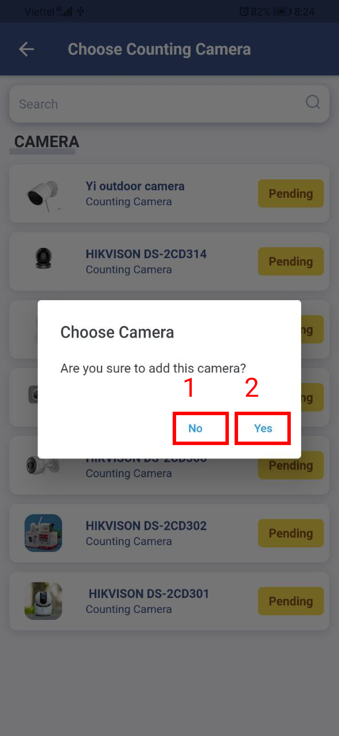

|  |  |
| --- | --- |
| **Step** | **Description** |
| 1 | Manager inputs the search value to find the counting camera by name. |
| 2 | Manager chooses the camera item. |
| 3 | Manager clicks the “No” button to cancel the command. |
| 4 | Manager clicks the “Yes” button to add the counting camera into the shelf. |

1. Remove the counting camera from the shelf



|  |  |
| --- | --- |
| **Step** | **Description** |
| 1 | Manager clicks the “No” button to cancel the command. |
| 2 | Manager clicks the “Yes” button to remove the counting camera from the shelf. |

**h. Stack detail page**

 

|  |  |
| --- | --- |
| **Step** | **Description** |
| 1 | Manager clicks the item to delete the stack. |
| 2 | Manager clicks the “add” icon to add the product into the stack. |
| 3 | Manager clicks the “add” icon to add the emotion camera into the stack. |
| 4 | Manager clicks the “remove” icon to remove the emotion camera from the stack. |
| 5 | Manager clicks the “remove” icon to remove the product from the stack. |

1. Detete the stack.



|  |  |
| --- | --- |
| **Step** | **Description** |
| 1 | Manager clicks the “back” icon to cancel the command. |
| 2 | Manager inputs an inactive reason. |
| 3 | Manager clicks the “Save” button to delete the stack. |

1. Add the product into the stack.

 

|  |  |
| --- | --- |
| **Step** | **Description** |
| 1 | Manager inputs the search value to find the product by name. |
| 2 | Manager chooses the product item. |
| 3 | Manager clicks the “No” button to cancel the command. |
| 4 | Manager clicks the “Yes” button to add the product into the stack. |

1. Add the emotion camera into the stack.

 

|  |  |
| --- | --- |
| **Step** | **Description** |
| 1 | Manager inputs the search value to find the emotion camera by name. |
| 2 | Manager chooses the emotion camera item. |
| 3 | Manager clicks the “No” button to cancel the command. |
| 4 | Manager clicks the “Yes” button to add the emotion camera into the stack. |

1. Remove the emotion camera from the stack.

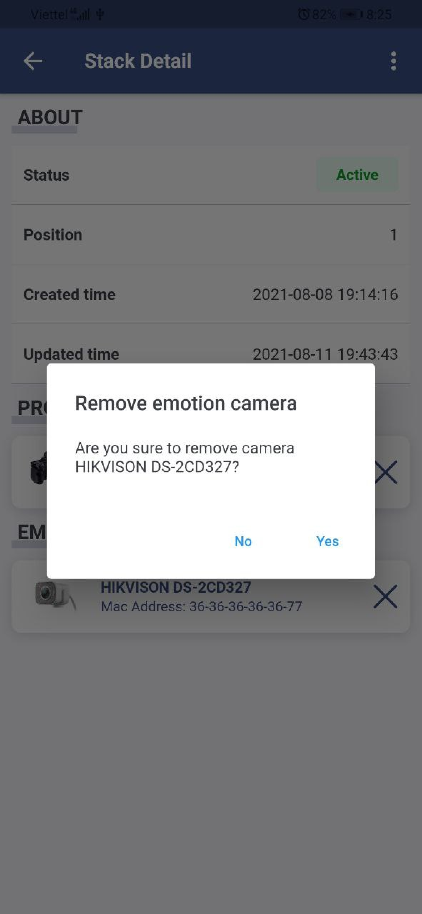

|  |  |
| --- | --- |
| **Step** | **Description** |
| 1 | Manager clicks the “No” button to cancel the command. |
| 2 | Manager clicks the “Yes” button to remove the emotion camera from the stack. |

1. Remove the product from the stack.



|  |  |
| --- | --- |
| **Step** | **Description** |
| 1 | Manager clicks the “No” button to cancel the command. |
| 2 | Manager clicks the “Yes” button to remove the product from the stack. |

**i. Camera page**



|  |  |
| --- | --- |
| **Step** | **Description** |
| 1 | Manager inputs the search value and chooses the value of filter. |
| 2 | Manager clicks the item to view the camera detai page. |

**j. Product page**



|  |  |
| --- | --- |
| **Step** | **Description** |
| 1 | Manager inputs the search value and chooses the value of filter. |
| 2 | Manager clicks the item to view the product detai page. |

**k. Category page**



|  |  |
| --- | --- |
| **Step** | **Description** |
| 1 | Manager inputs the search value and chooses the value of filter. |
| 2 | Manager clicks the item to view the category detai page. |